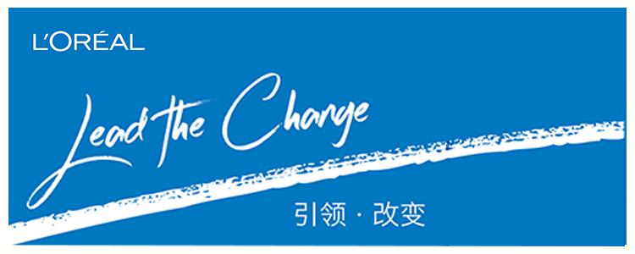
L’Oreal China Research & Innovation Center 2018 Summer Intern Program is coming!
2018欧莱雅研发中心暑期实习生项目开始啦！

If you major in Chemistry, Material Science, Biology, Medicine and Pharmacy; if you are passionate about beauty industry; if you are innovative…Then don’t be hesitating. Come and apply for L’Oreal China R&I Center Summer Intern Program! We are here to create the miracle of beauty industry. Welcome to join us and bring your talent, your dream, your innovation as well as your passion to L’Oreal.
如果你是化学、材料、生物、医药等相关理工科专业的技术牛人；如果你对美的事业充满热情，有志加入美的行业；如果你既能脚踏实地，又能仰望星空，创意无限……那还等什么？赶快加入欧莱雅研发中心暑期实习生项目！将你的才华与梦想，你的创意与激情统统转化为成功的动力，与我们一起创造美丽的奇迹！

In two-month summer intern duration, you will take ownership on one specific research assignment; get intensive training and interaction opportunity with L’Oreal R&I expert. In addition, you’ll be invited to lots of interesting activities which will help you build up your network as well as improve communication & leadership skill!
在这里，你将会获得一个历时2个月的暑期实习计划，你将独立完成一个特定的研发项目，参加各项培训课程，聆听欧家大牛分享经验，此外，还有丰富的团队建设等活动，帮助你迅速提升沟通、组织、管理等多种能力！
Good performer will be selected into 2019 Management Trainee Program.
在暑期实习生项目中表现优异的学生将有机会直接进入2019欧莱雅研发中心管理培训生的最终面试，拿到令人艳羡的2019管培生offer!!!

Internship period: July 2nd 2018 – August 31th 2018
实习时间：2018年7月2日-2018年8月31日

Target students: Student with China working visa, Master & above who will graduate in 2019 (Major in Chemistry, Material Science, Biology, Medicine and Pharmacy)
申请对象：将于2019年7月1日前毕业的硕士及以上学历(化学、材料、生物、医药等相关专业)学生，具备中国工作签证

申请方式：请扫描以下二维码，完成你的网上注册
Application way: Please scan the QR code to start your online registration.

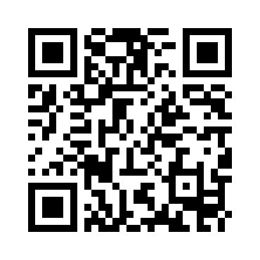

通过网申初筛的学生还将有机会参加研发Open Day，届时将由美女科学家带大家亲临高大上的研发实验室，见证美的奇迹如何诞生！
Students who pass the primary interview will be invited to the Open Day in L’Oréal Research & Innovation Center.

