Christiane Barranguet studied oceanography in Uruguay and completed a DEA and a PhD in Oceanography in Marseille, France. After graduation, Christiane worked at the two major institutes for marine research in the Netherlands (NIOO and NIOZ), and later on at the University of Amsterdam, where besides her research work she mentored MSc, PhD and Post-doctoral students. Christiane has published over 30 scientific publications in international journals.
In 2004 she joined Elsevier to reposition the publication policy and manage the top international scientific journals in water research. Christiane developed information solutions around water research and technology including scientific conferences, new products and cooperation with NGO’s. Christiane was the publishing director of the Computer Science and Industrial Manufacturing group at Elsevier before moving to her present position.
Since 2016, Christiane has been Publishing Director Material Sciences, leading a group of 7 publishers who manage over 70 research journals, the electronic platform MaterialsToday.com and several scientific conferences. The group is also committed to highlight the societal impact of materials science by helping researchers communicate materials science to decision makers and the public; fostering diversity and inclusion and rewarding outstanding research and agents of change. Christiane has been encouraging geographical and gender representation internationally by giving workshops, lectures and inviting the dialogue during international conferences.

Christiane Barranguet

Tingting Zou has been a Publisher in Elsevier’s Materials Science group since 2010, principally looking after journals related to composites and metals, as well as some broader materials titles, including Composites Science and Technology, Composites Part A and B, Composite Structures, Cement and Concrete Composites, Carbon, Materials Science and Engineering A, etc. Her role also involves developing Elsevier’s Materials Science journal program in Asia with a particular focus on journal partnership and promoting editorial presence in the region.
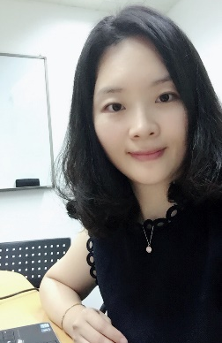
Tingting Zou

